Unity Bootcamp - Creating a 2D Game

Part 7 - Audio

# 

# Music

Go onto the internet and download a song for your game. Then import it into your project.

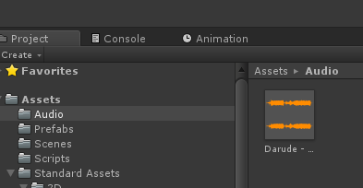

Import the ***Music*** package. Then in prefabs, find the Music prefab and in the Audio Source component, set your song as the *AudioClip* (first variable).

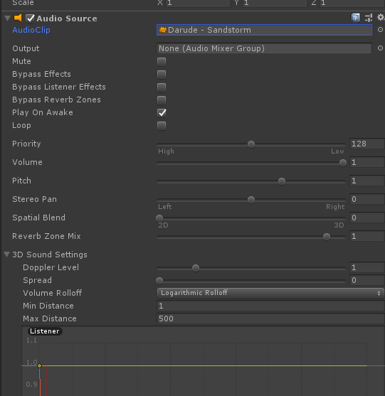

Now drag the prefab into the menu scene, the music will play throughout your game.

# Level complete & death sounds

You may have noticed the *Game Manager* had two fields we didn’t use earlier.

Import some sounds into your game (freesounds.org is a good site to find sounds).

Find the *Game Manager* prefab in the *Project Window* and set the audio clips in the inspector.